# 

**FATIMA JINNAH WOMEN UNIVERSITY RAWALPINDI**

Department of Software Engineering

**NAME: SHUMAIL ZAHRA REGISTRATION #: 2023-BSE-061 DEPARTMENT: BSE**

**SEMESTER: 5B**

**SUBMITTED TO: Sir Waqas Saleem**

**Date: 12/10/25**

**Cloud Computing**

**Assignment**

**Task 1: Run Gitea in Codespace and Create an Initial Repo**

1. **Set up Gitea:**
   * Run a Gitea server inside your Codespace.
   * Use HTTPS for communication (SSH is not supported in Codespace).
2. **Create a Repository:**
   * Create a new repository on your Gitea server.
   * Add a README.md file **listing each student's name and roll number**.
   * Push your initial commit containing the README.md to Gitea.

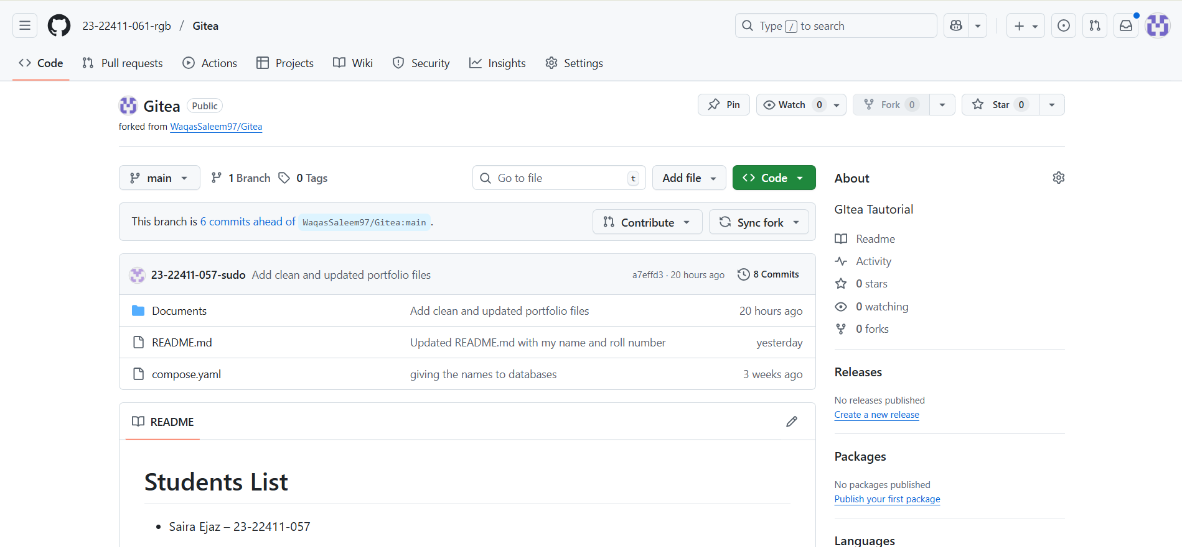

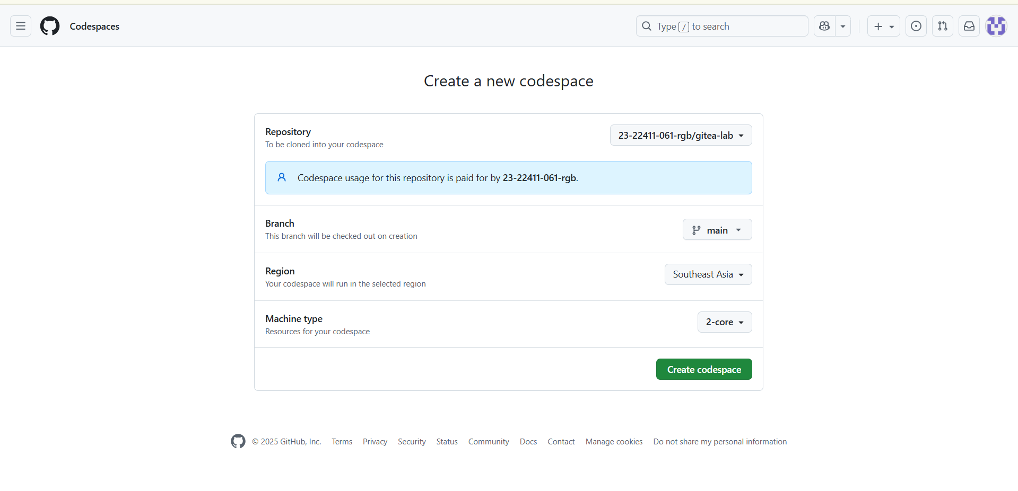

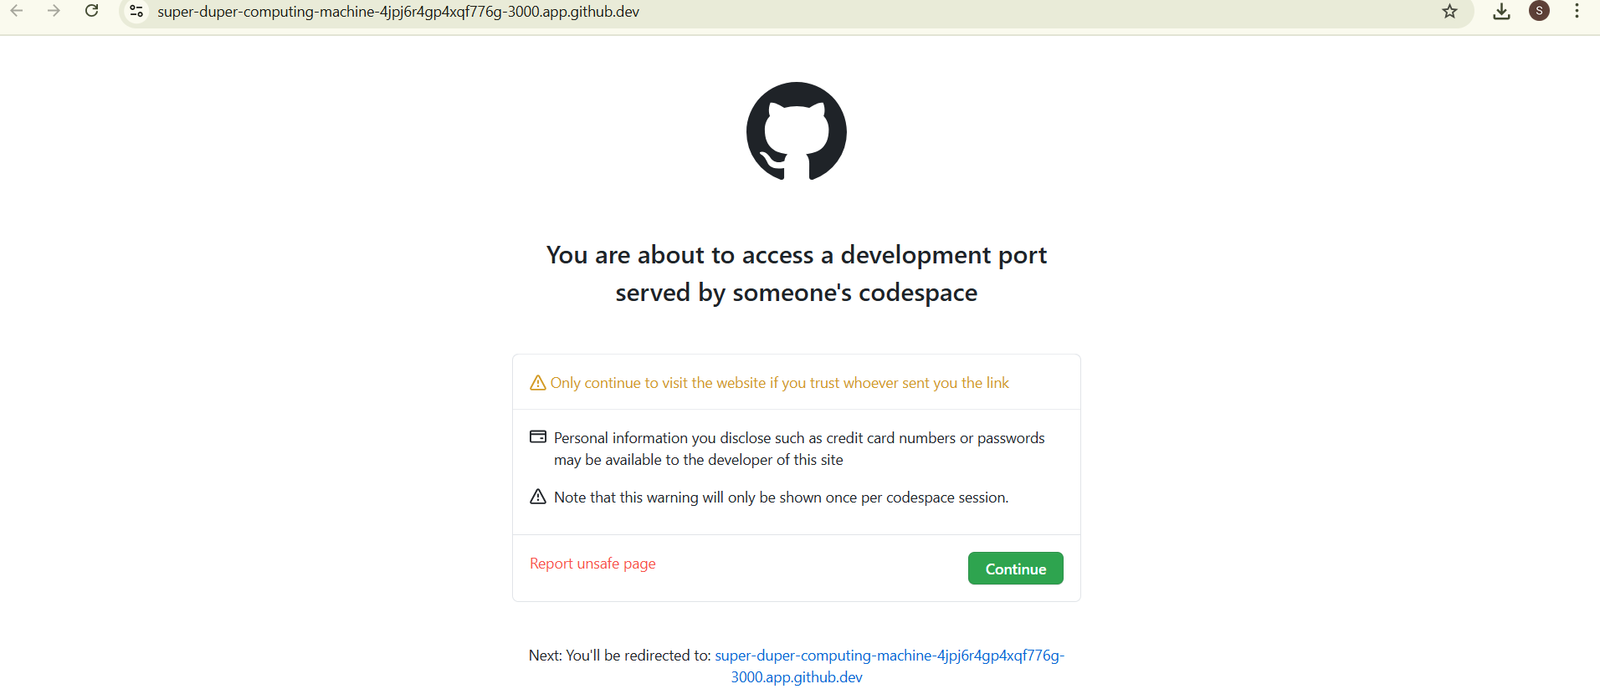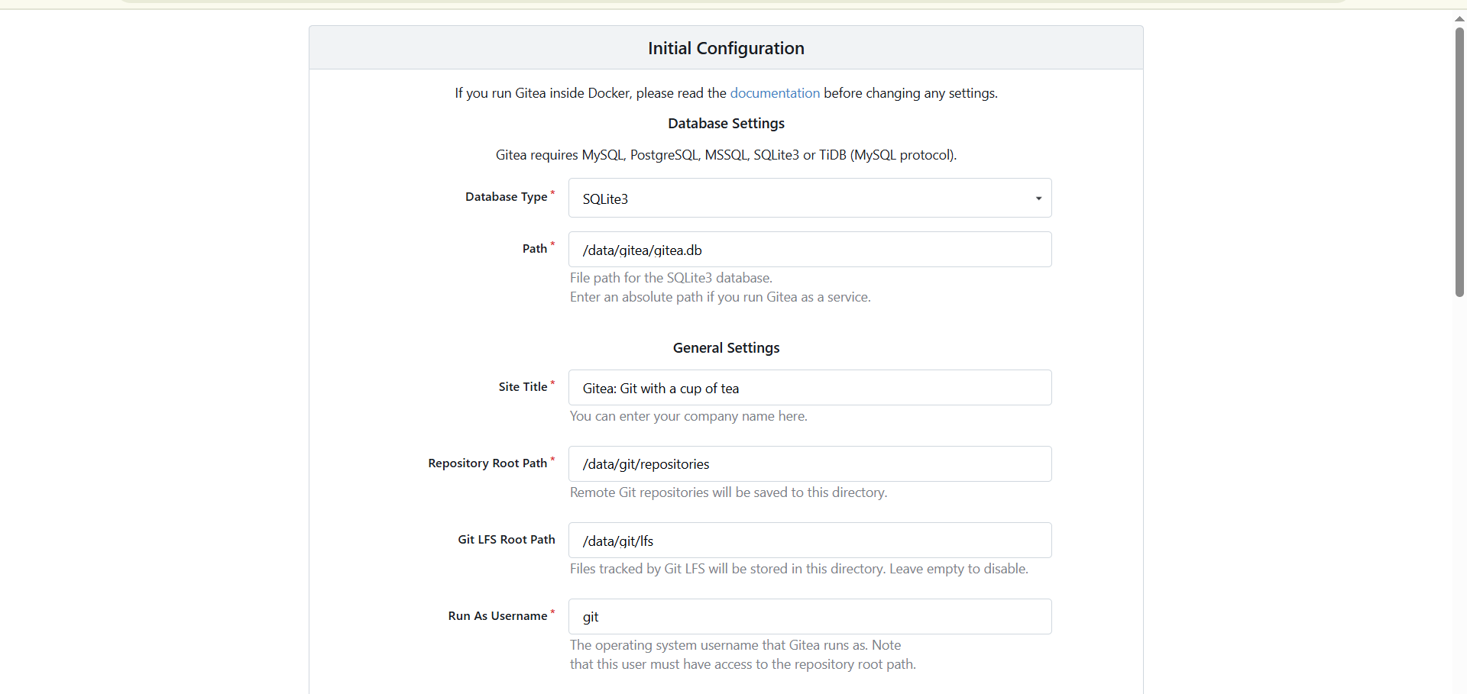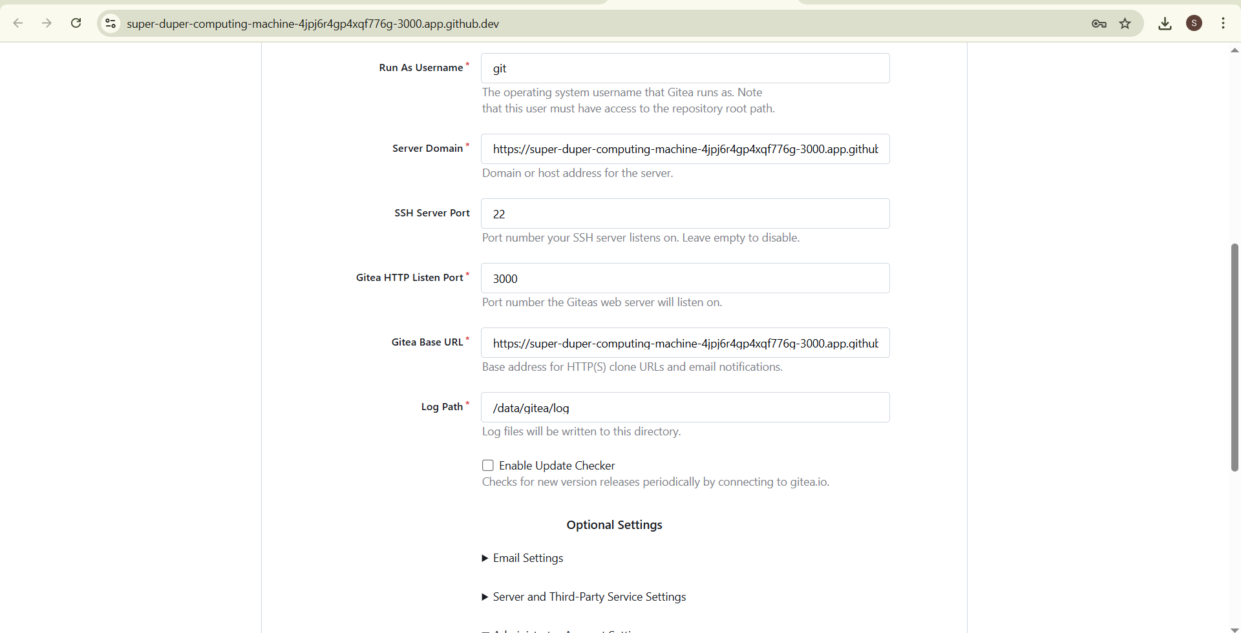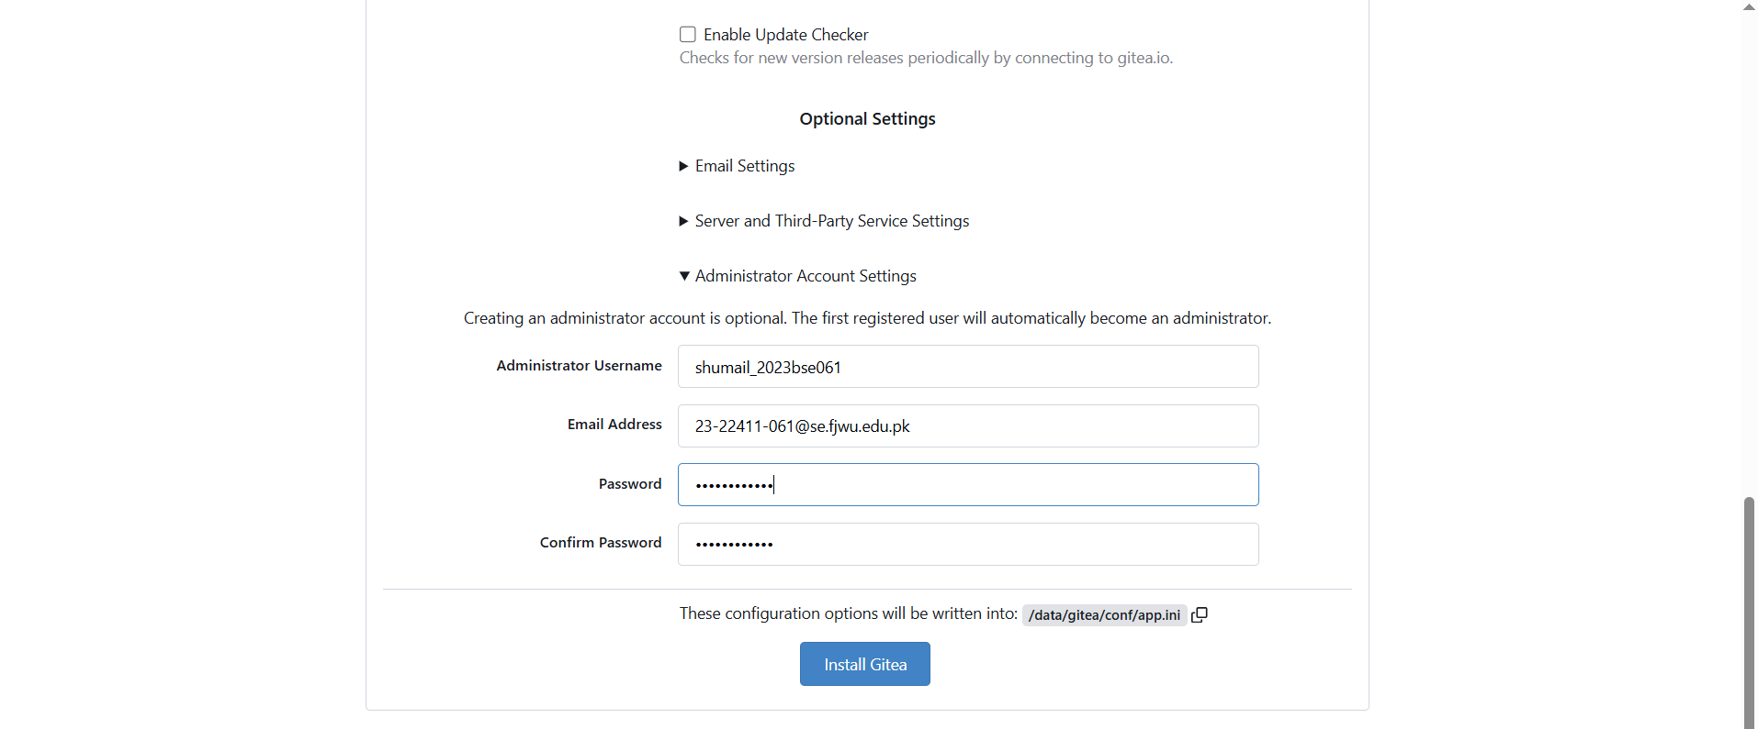

<https://opulent-goggles-q7576xr9j764fx99q-3000.app.github.dev/shumail_2023bse061/gitea_test>

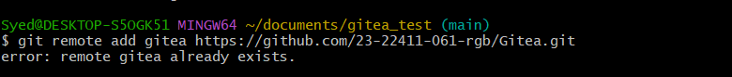

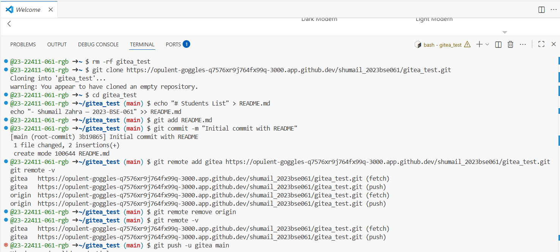

**Gitea Server Connection with Git Bash**

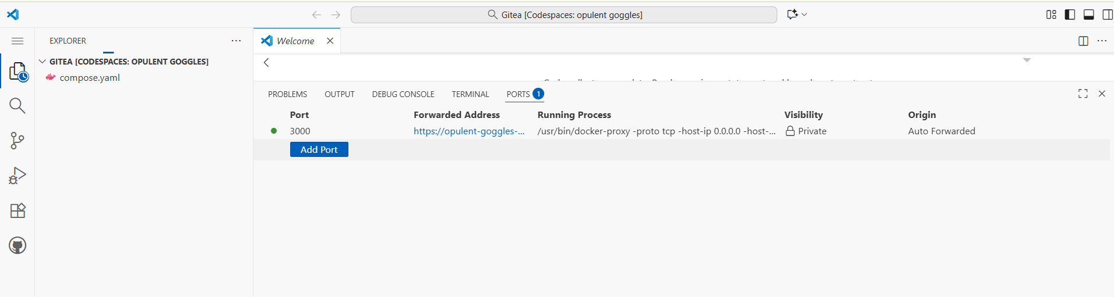

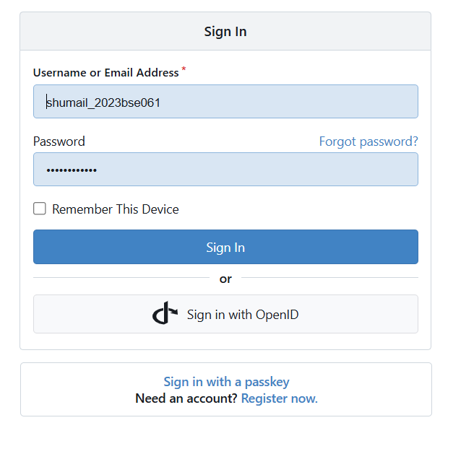

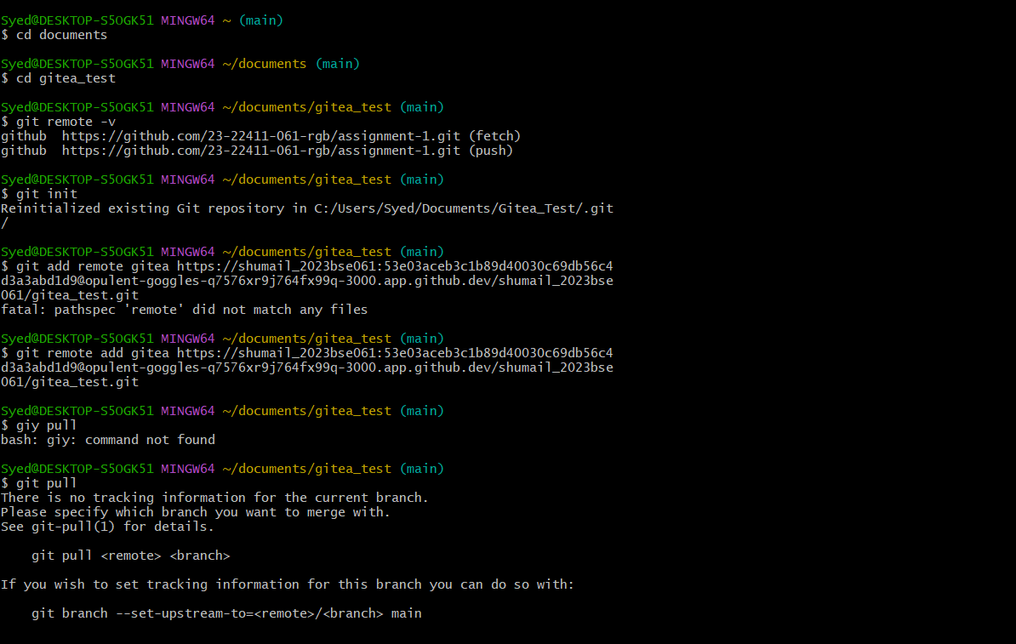

[**https://opulent-goggles-q7576xr9j764fx99q-3000.app.github.dev/shumail_2023bse061/gitea_test/src/branch/main/**](https://opulent-goggles-q7576xr9j764fx99q-3000.app.github.dev/shumail_2023bse061/gitea_test/src/branch/main/)

1. **Add Remote Repo:**
   * Use the following command to add your Gitea repository as a remote:
   * git remote add gitea <your_gitea_repo_https_url>

**Task 2: Mirror README.md from Gitea to GitHub**

1. **Continue Working with Your Existing Repository:**
   * You will use the same repository that you created and pushed to your Gitea server in Task 1.

1. **Create GitHub Repository:**
   * Create a new GitHub repository named assignment 1.

1. **Add GitHub as a Second Remote:**
   * Add your GitHub repository as a remote to your local repository:
   * git remote add github <your_github_repo_https_url>

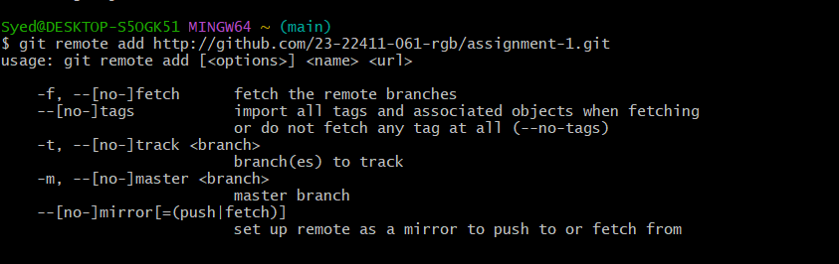

1. **Push the README.md File to GitHub:**
   * Push the contents (including the README.md) from your local repository to GitHub.

1. **Verify Remotes:**
   * Run git remote -v and ensure both remotes (gitea and github) are listed.

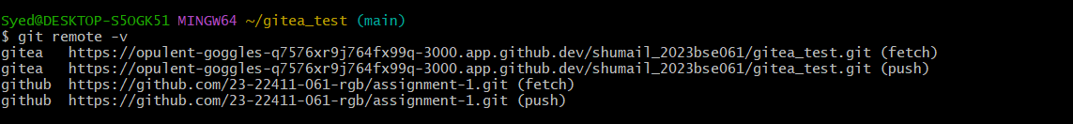

**Task 3: Use Git LFS for Large Files**

[**https://github.com/23-22411-061-rgb/assignment-1**](https://github.com/23-22411-061-rgb/assignment-1)

1. **Install Git LFS:**
   * Set up Git LFS in your local repository.
2. **Add Large Files:**
   * Add **three files larger than 100 MB** each to your repository.
   * Track them using Git LFS:
   * git lfs track "*.ext"

Replace .ext with the appropriate file extension.

1. **Reference in Assignment Repo:**
   * Commit and push these large files to your GitHub assignment 1 repo.
   * Ensure the files are referenced correctly in your repository history.

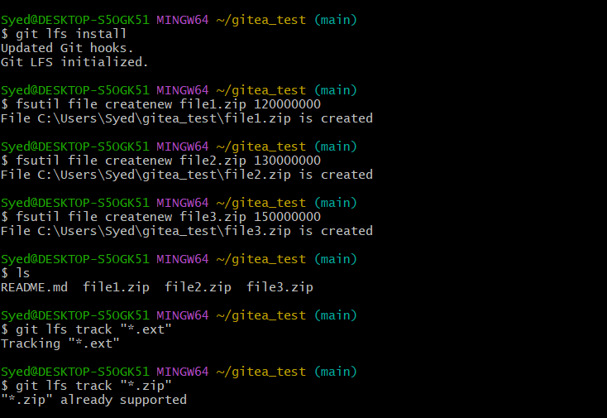

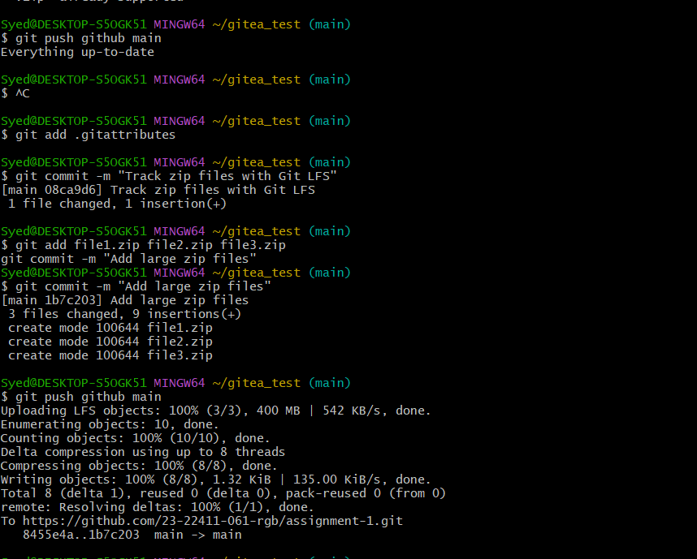

**Task 4: Create a Portfolio/CV with GitHub Pages**

1. **Create a new repository for GitHub Pages:**
   * Create a new repository named <your-username>.github.io.
   * Replace <your-username> with your actual GitHub username (e.g., johnsmith.github.io).
2. **Design Your Portfolio/CV:**
   * Create your portfolio or CV in HTML/CSS (or use a static site generator).
3. **Publish with GitHub Pages:**
   * Push your portfolio/CV files to the <your-username>.github.io repository.
   * Enable GitHub Pages in your repository settings if not automatically enabled.
   * Publish your site and share the link.

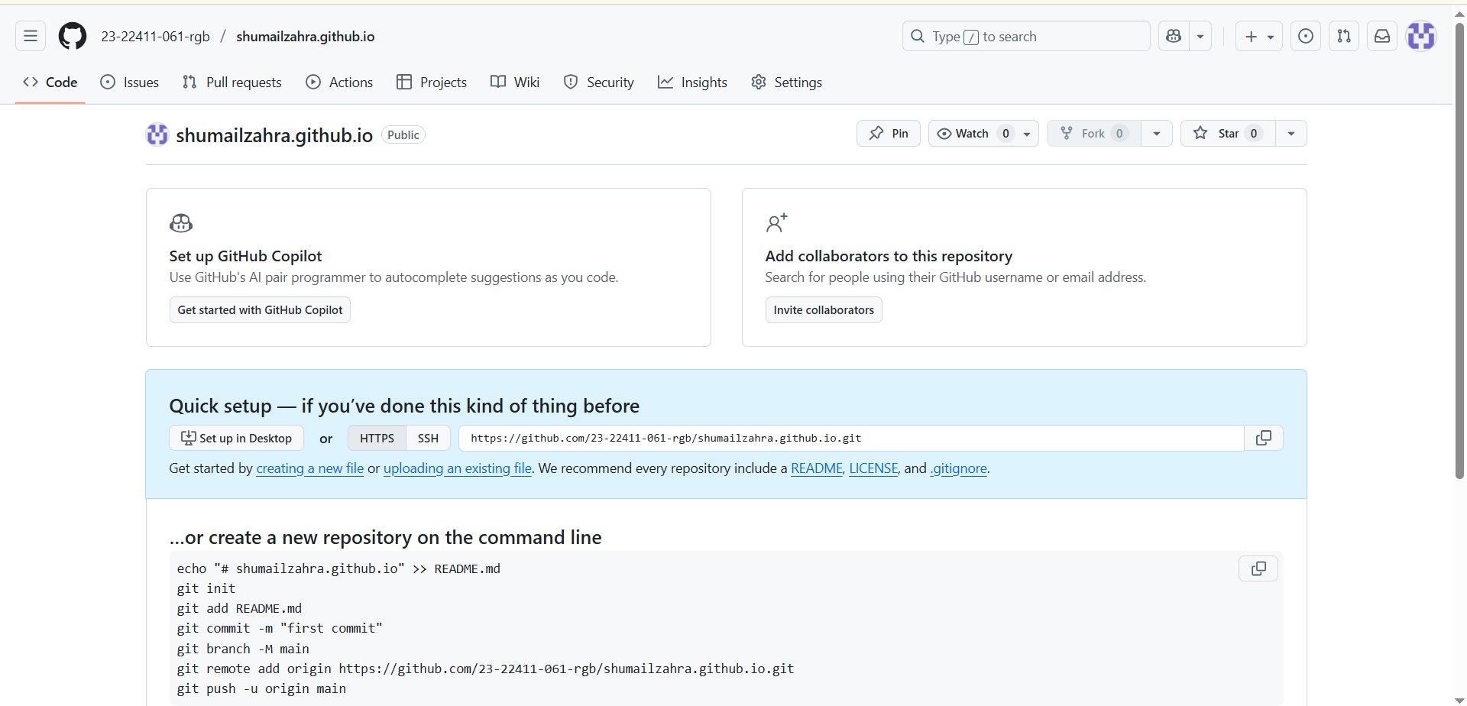

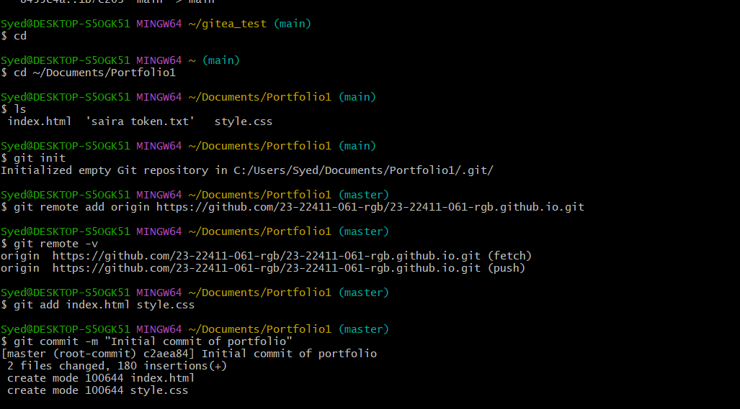

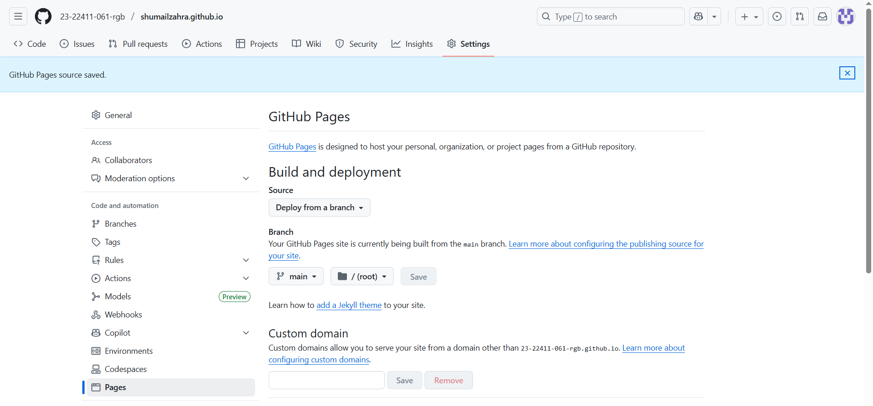

**GitHub Pages link**

<https://23-22411-061-rgb.github.io/>